PROJECT TESTING PHASE
Blog Nest

Project Title:
Blog Nest – An AI-Powered Backend for Publishing and Managing Blogs
Team ID : SWTID-2026-6013
Team Size : 4
Team Leader : MADHUMITHA J
Team member :
MADHUMITHA J
SHALINI G
SIVATMIKA ANAND
JAINA S

1. Purpose of Testing
In this phase we checked that the Blog Nest backend behaves as designed: users can sign up and log in securely, blog posts can be created and managed, the AI assistant can write and condense content, and bad input is rejected cleanly. Every endpoint was called from Postman and its JSON reply was compared with what we expected.

🔐  SECURE LOGIN  JWT tokens, hashed passwords | 🤖  AI WRITING  Draft and shorten posts | 📚  BLOG POSTS  Add, view, edit, delete | 🧪  API CLIENT  Postman
2. How a Request Travels
POSTMAN REQUEST → EXPRESS SERVER → TOKEN CHECK / AI SERVICE → MONGODB STORAGE → JSON REPLY

3. Results at a Glance
Area Tested | No. of Cases | What We Expected | Outcome
User Accounts | [ ] | Sign-up, login and token-guarded routes | [PASS / FAIL]
AI Assistant | [ ] | Blog draft and summary returned | [PASS / FAIL]
Blog Posts | [ ] | Create, read, update, delete | [PASS / FAIL]
Input Checks | [ ] | Wrong or missing data rejected | [PASS / FAIL]
Data Storage | [ ] | Records saved and fetched correctly | [PASS / FAIL]

4. Postman Screenshots
Add your own Postman screenshots in the boxes below, showing each request together with its response.

01 • NEW USER SIGN-UP
Sign-up request, body sent and success reply

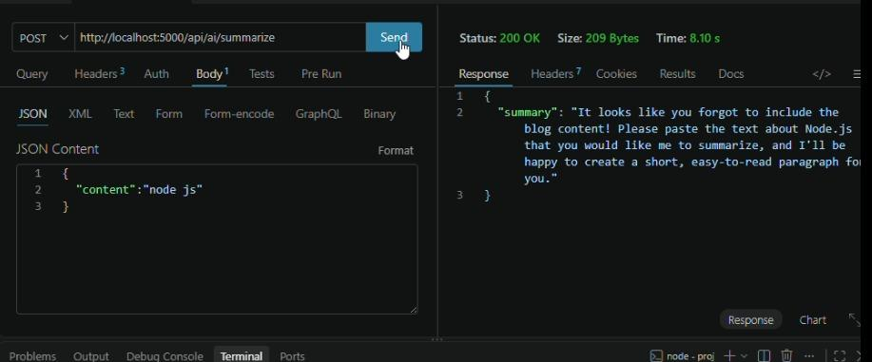

02 • USER LOGIN
Login request, token returned and status code
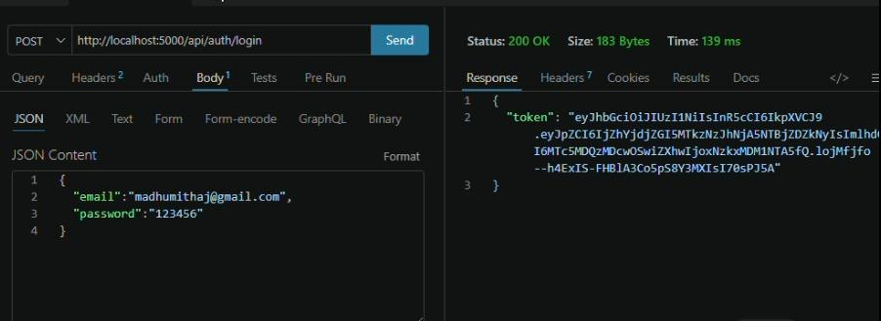

03 • ADD A BLOG POST
Post-creation request with data and success reply
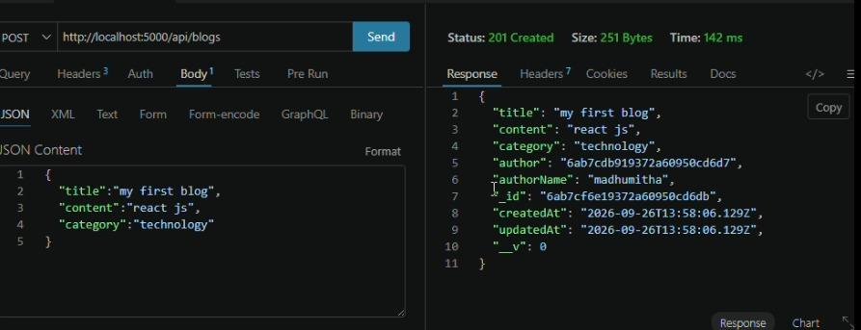

04 • AI-WRITTEN BLOG
Topic and category sent, AI-written blog returned
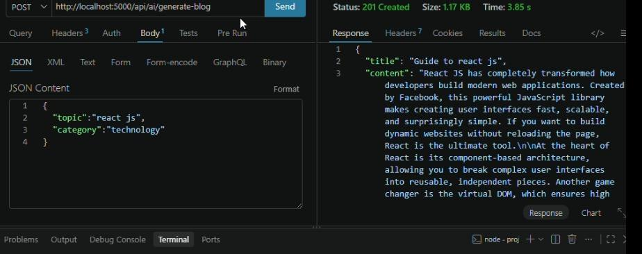

05 • AI SUMMARY
Text sent for summarizing and the summary returned

5. Tools and Remarks
Tools used: Postman | Node.js with Express | MongoDB | JWT and bcrypt | Generative AI service
The screenshots above document sign-up, login, blog creation, AI blog writing and AI summarizing.

AI Blog Nest API Testing :API TESTING VIDEO

